Workplace Address |  |  |  | Date | / /
Risk Address |  |  |  | Prepared by
Planning team names
Use this High Risk Plan to assist planning and documentation of high risk activities. Where insufficient space to fully detail matters, add & insert page from rear. For Demolition, use AC Removal & Demolition Plan.
THIS HIGH RISK PLAN CONTAINS
GENERAL INFORMATION | About the high risk activity
HIGH RISK ACTIVITY & SITUATION | Understand the high risk activity & situation
START UP ACTIVITIES | Get information & prepare the activity workplace
ENVIRONMENT RISK ASSESSMENT | Hazards & controls other than activity hazards
ACCESS CONTROL & SERVICES | Public & workers access control and services
ACTIVITY PROCESS | Plan the activity process, step by step
SAFE WORK METHOD STATEMENT | Identify hazards, controls & responsibilities
STRUCTURAL MATTERS | Include structural engineering matters
HEALTH & SAFETY MATTERS | Include health & safety matters
ADDITIONAL INFORMATION | Blank form

GENERAL INFORMATION About the high risk activity
Activity Description (brief) |  |  |  |  |  |  |  | Situation | Circle as relevant
 |  |  |  |  |  |  |  | Access by | Workers Pedestrians Public
 |  |  |  |  |  |  |  |  | Cars Trucks other Vehicles Air Sea
 |  |  |  |  |  |  |  | Land | Office Retail Entertain Farm Accom
 |  |  |  |  |  |  |  | based use | Production Storage Warehouse Special
 |  |  |  |  |  |  |  | Structural
 |  |  |  |  |  |  |  | System
 |  |  |  |  |  |  |  | Floor | Rock |  | Soil | Timber | Conc
Work Hours | Start |  |  | Finish |  |  |  | Structure | Conc |  | Steel | Timber |  | Alum
Worker No’s | 1 – 5 | 6 – 10 |  | 10 –20 |  |  | >20 | Cladding | Steel |  | Brick | Alum |  | Glass
Exit points | 1 | 2 |  | 3 |  |  | >3 | Roof | Sheet |  | Tile | Traff |  | Glass
Emergency Plan | Assess | Plan |  | Notify |  |  | Post | Levels | 1 |  | 2 | 3 |  | >3
Confined Space |  |  | Yes |  |  | No |  | Sea / Air based use
Extreme Temperatures |  |  | Yes |  | No |  |  | Proximity | Collision objects Vessels Landing points
Structural Engineer Name |  |  |  |  |  |  |  |  | Land
Other Information

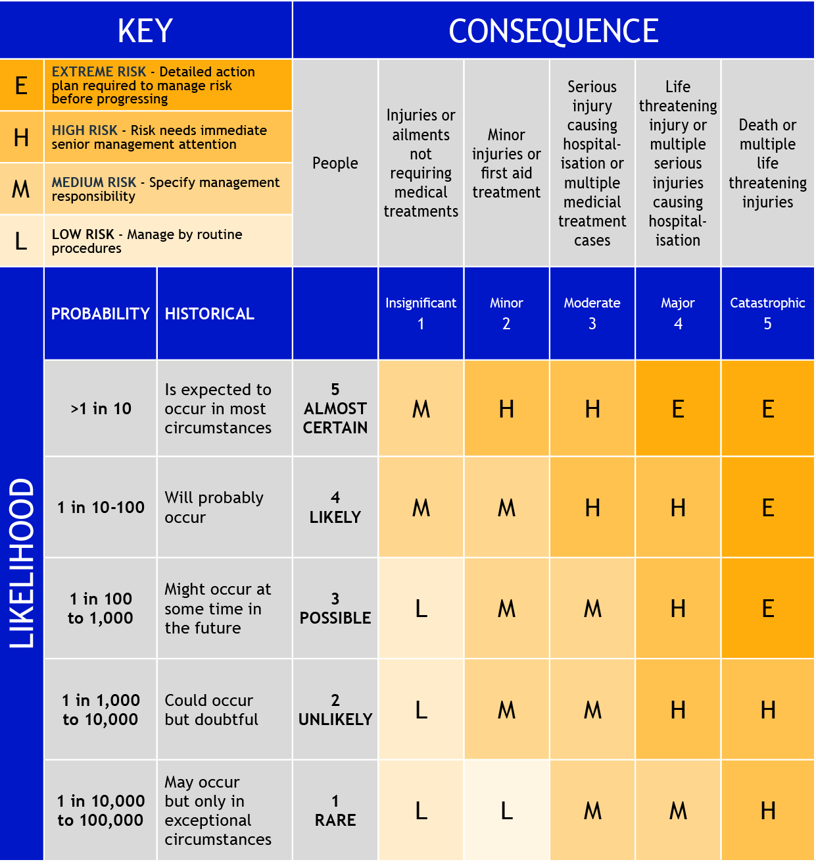
WHAT IS HIGH RISK and needing a High Risk Plan
Work out High, Medium or Low Risk using the occurrence probability and consequence table below. If Risk assessed as High, then High Risk Plan required. Be realistic, ask “Can I, my fellow employees, visitors or the public be harmed by a fall, slip, trip, caught in or by, be electrocuted, crushed, struck, get stuck, contacted by, be exposed to a substance, fume or radiation, sunlight, or any other harmful action or thing”

HIGH RISK ACTIVITY & SITUATION Understand high risk activity & situation

Describe, show high risk activity & situation, workplace, property & structures, describe neighbours, identify underground & overhead features. Show dimension & location features like large trees, obstructions, etc.

- Examine all aspects of the activity, workplace, property, structures, buildings
- Location and extent of any underground structures such as basements, cellars, wells or storage tanks
- Consider removal effect of cross walls and superstructure load on the stability of basement walls, etc
- Location and extent of retaining structures which support adjoining ground or buildings
- Consider easements, right of way, boundary walls and other encumbrances
- Where neighbouring properties need protection, prepare protection plan, obtain property owners approval

START UP ACTIVITIES Getting information and preparing the activity location
 | Status |  |  | Status
Documentation | Circle |  | Consult with employees, stakeholders | Circle
Insurance –Public Liability | na | Done | Discuss High Risk Plan, issues, modify, | na | Done
Obtain drawing, structure, services | na | Done |  | na | Done
Obtain & review Engineers Report | na | Done |  | na | Done
Determine Activity Process | na | Done | Location preparation, as required
Prepare High Risk Plan | na | Done | Conduct Workplace Risk Assessment | na | Done
Obtain municipal, roads, police permit | na | Done | Erect fences, barriers, signage | na | Done
High Risk Plan copy to Up-line Manager | na | Done | Disconnect electrical, gas, water, sewer | na | Done
OHS doc’s Emergency Procedure, | na | Done | Arrange Toilet and other amenities | na | Done
Safe Work Method Statements, | na | Done | Arrange decontamination unit, | na | Done
Induction, Injury Incident, Hazard | na | Done | Arrange disposal, bin, EPA approve dump | na | Done
 |  |  | Notify occupants, neighbours | na | Done
Specialist Reports |  |  | Arrange plant & equipment | na | Done
 | na | Done |  | na | Done
 | na | Done |  | na | Done
 | na | Done |  | na | Done
Notifications |  |  |  | na | Done
Notify Regulator | na | Done |  | na | Done
 |  |  |  | na | Done

ENVIRONMENT RISK ASSESSMENT Hazards & controls other than activity hazards
Hazard Description | Risk Level | Control measure | Req’d?
 | Circle |  | Circle
Animals interference | E H M L na | Request to constrain Request council to act | yes no
Drug Wastage | E H M L na | Have removed by trained person, clear area | yes no
Electrocution & energy sources | E H M L na | Check systems, protect RCD’s, test & tag | yes no
Environment contaminants like | E H M L na | Obtain Contaminants Report | yes no
asbestos, lead, carbons, other | E H M L na | Dispose, isolate, cover, test, regularly monitor | yes no
Falls hazards | E H M L na | Eliminate, provide protection | yes no
Infectious hazards | E H M L na | Remove, isolate, regularly monitor | yes no
Materials handling, loading, etc | E H M L na | Provide clear, trip, slip free, level surfaces | yes no
Nearby public & tenants are |  |  | yes no
- Abusive, Aggressive | E H M L na | Ask to refrain, involve authorities | yes no
- Intrusive | E H M L na | Erect barrier or fence | yes no
Nearby public effected by |  |  | yes no
- Noise, dust | E H M L na | Replace, muffle, wet, restrict source hours | yes no
- Language, behaviour | E H M L na | Muffle source, remove offender from site | yes no
Overhanging trees, branches | E H M L na | Remove overhanging intrusions | yes no
Overhead electrical, other | E H M L na | Disconnect, isolate, cover, make known to all | yes no
Underground sewer, services | E H M L na | Disconnect, isolate, mark out, advice all | yes no
Unable to locate contaminants | E H M L na | Retrace id items, carefully remove, load & dispose | yes no
Vandalism, loss & damage | E H M L na | Erect barrier or fence | yes no
Vehicles entering, leaving | E H M L na | Erect barrier or fence, Post warning signs | yes no
 | E H M L na | Use flagmen when entering / leaving | yes no
Add other control measures as needed.

ACCESS CONTROL & SERVICES
Public & worker access control and services

Sketch access and boundary controls, barriers, entry & exit points, location and type of services entering or on workplace. What protection actions to be taken

Consider location and condition of drainage, sewerage, electricity, gas, water, telephone cables, radio & television relay lines, hydraulic pressure mains, liquid fuel lines, lubrication lines, process lines (chemical, acid), any hazardous materials including asbestos and synthetic fibres.

ACTIVITY PROCESS Plan the activity process, step by step.

Step 1. Describe high risk activity. Show plan and elevations. Show dimensions

Step 2. Show elements in high risk activity sequence. Draw sketches, show protection & support methods.

Step 3. Detail disposal method and location for waste materials

SAFE WORK METHOD STATEMENT Identify hazards, controls & responsibilities
Task
Task Description
Prepared by |  |  |  |  | Reviewed By
References. Act, Regulation, Code of Practice (COP), Industry Standard (IS), Aust Stand (AS), Standard
Action (SA). OHS Act 2004, OHS Regulations 2007
COP Manual Handling, COP Plant, COP Hazardous Substances, CC Prevention of Falls in General Construction
COP Demolition
Task  Detail tasks required to perform activity in sequence they are to be carried out |  | Hazard  What hazards may cause injury | Control Measure  List those required to eliminate or minimise risk of injury from identified hazard |  |  |  | Person Responsible  To implement controls | Check  Tick when done
Team sign off Name |  | Signature | Date | Action required |  | Copies To |  | Date
 |  |  |  |  |  | Up-line Manager
 |  |  |  |  |  | Worker HSR
 |  |  |  |  |  | OHS Committee
 |  |  |  | Manager

STRUCTURAL MATTERS Include structural engineering matters
Engineer: when and how will engineer participate in & sign off high risk plan and progressive activity phases.

Structural members: what, how, when and where will they be identified.

Support methods: what, when, where and how they will be positioned, when and how they can be removed.

Machinery: what will be used, where it is positioned, how it gets there and how it is removed.

Other matters: Include as required

Describe and detail structural engineering matters

HEALTH & SAFETY MATTERS
Include Health & Safety and other matters as required | Status
MATTER | Circle
Access equipment Check scaffolds, elevating platforms, booms, ladders, hoists, boxes, etc | n/a | done
Access Points Clearly marked & controlled | n/a | done
Amenities Provide amenities as per Regulations & Codes | n/a | done
Alcohol & Drugs Be aware of consequences of alcohol & drug consumption and / or influence | n/a | done
 | n/a | done
 | n/a | done
Competency Check, ensure workers competent to do tasks, operate plant, equip & tools | n/a | done
Contaminated materials Removed prior to activity | n/a | done
Consultation All workers and visitors consulted in high risk planning | n/a | done
 | n/a | done
 | n/a | done
Debris & Rubble Areas cleared, known to all, install barriers, install chutes, drop zones clear | n/a | done
Discovery Full search for hidden structures, persons, carried out before commencing work | n/a | done
 | n/a | done
 | n/a | done
Egress Paths Clear, well light | n/a | done
Emergency Contacts Detail and post | n/a | done
Emergency Response Procedure Prepare, discuss, agree, posted | n/a | done
Evacuation Procedure Ensure method of notifying workers, egress paths clear & known | n/a | done
 | n/a | done
Fall protection Install & use as per Regulations and SWMS Working at Heights | n/a | done
Fire Fighting Extinguishers, other equipment ready, suitable, persons trained in use | n/a | done
First Aid Provide first facilities and first aiders as per Regulations & CC First Aid | n/a | done
 | n/a | done
 | n/a | done
Heavy plant & equipment Work surfaces stable, supported, clear, certified by engineer | n/a | done
 | n/a | done
 | n/a | done
Induction All persons involved inducted including visitors, contractors, engineers, etc | n/a | done
 | n/a | done
 | n/a | done
Openings Protect, close, cover openings | n/a | done
Overloading Check loadings, ensure debris removed to prevent overloading | n/a | done
 | n/a | done
 | n/a | done
Plant & Equip Suitable, well maintained, ready for use, fitted with muffler, silencer, etc | n/a | done
Protective gear Available, suitable and ready for use. Respiratory, ear, eye, foot, hands, etc | n/a | done
Protective structures Installed and suitable | n/a | done
Public Protection Installed, barriers, no access without permission | n/a | done
 | n/a | done
 | n/a | done
Services All services located, isolated, cut off | n/a | done
Signage Warning & access signs in place | n/a | done
Supervisor Competent supervisor on location at all times | n/a | done
Support systems Installed to engineers requirements, suitable, | n/a | done
 | n/a | done
 | n/a | done
Work Surfaces Stable, clear, suitable to work on | n/a | done
 | n/a | done
 | n/a | done
 | n/a | done
 | n/a | done
 | n/a | done
 | n/a | done
 | n/a | done
 | n/a | done
 | n/a | done
 | n/a | done

ADDITIONAL INFORMATION Blank form

