Workplace Address |  |  |  |  |  |  |  |  |  |  |  |  |  |  |  |  |  |  |  |  | Date Notified |  |  |  |  |  |  |  | / /
Principal Contact |  |  |  |  |  |  |  |  |  |  |  |  |  |  |  |  |  |  |  |  | Injury No
What is this Injury Illness about? Circle |  |  |  |  |  |  |  |  |  |  |  |  |  |  | INJURY |  |  |  |  |  |  |  | ILLNESS

Employer name and address
Name |  |  |  |  |  |  |  |  |  |  |  |  |  |  |  |  |  | Phone

Address

PERSON PARTICULARS
Name |  |  |  |  |  |  |  |  |  |  |  |  |  |  |  |  |  | Date of Birth
Address |  |  |  |  |  |  |  |  |  |  |  |  |  |  |  |  |  | Gender |  |  |  |  |  |  |  |  | M |  |  |  |  |  | F
Occupation |  |  |  |  |  |  |  |  |  |  |  |  |  |  |  |  |  | Marital Status

INJURY / ILLNESS PARTICULARS
Location |  |  |  |  |  |  |  |  |  |  |  |  |  | Date |  |  |  | Time |  |  |  | am/pm

Description
Task being undertaken at time of injury (identify any plant, substance or equipment)
Nature of Injury / Illness |  |  |  |  |  |  |  |  |  | Cause of Injury / Illness
Action taken to prevent reoccurrence |  |  |  |  |  |  |  |  |  | Treatment Given
 |  |  |  |  |  |  |  |  |  | Time Lost by Injured person |  |  |  |  |  |  |  |  |  |  |  |  |  |  | Hours

PERSONS WHO SAW INCIDENT OR FIRST CAME TO SCENE
Name |  |  |  |  |  |  |  |  |  |  |  |  |  |  |  |  |  |  | Phone
Name |  |  |  |  |  |  |  |  |  |  |  |  |  |  |  |  |  |  | Phone
FIRST AID RECORDS
First Aid Attendant Name
Was Worker Referred For Further Treatment? |  |  |  |  |  |  |  |  |  |  |  |  |  |  |  |  |  |  |  |  |  |  |  |  |  | Yes |  |  |  |  |  | No
If Yes, Give Details
Present Medication |  |  |  |  |  |  |  |  |  |  |  | Tetanus Coverage |  |  |  |  |  |  |  | Less than 2 years
Allergies |  |  |  |  |  |  |  |  |  |  |  |  |  |  |  |  |  |  |  | More than 2 years
Other medication |  |  |  |  |  |  |  |  |  |  |  |  |  |  |  |  |  |  |  | Never
PERSONS MAKING ENTRY
Worker |  |  |  |  |  |  |  |  |  |  |  | Employer of Injured / Ill worker
Name |  |  |  |  |  |  |  |  | Date |  |  |  | Name |  |  |  |  |  |  |  |  |  |  |  |  |  |  |  |  |  | Date
Signature |  |  |  |  |  |  |  |  |  |  |  |  | Signature

Mark up injury details

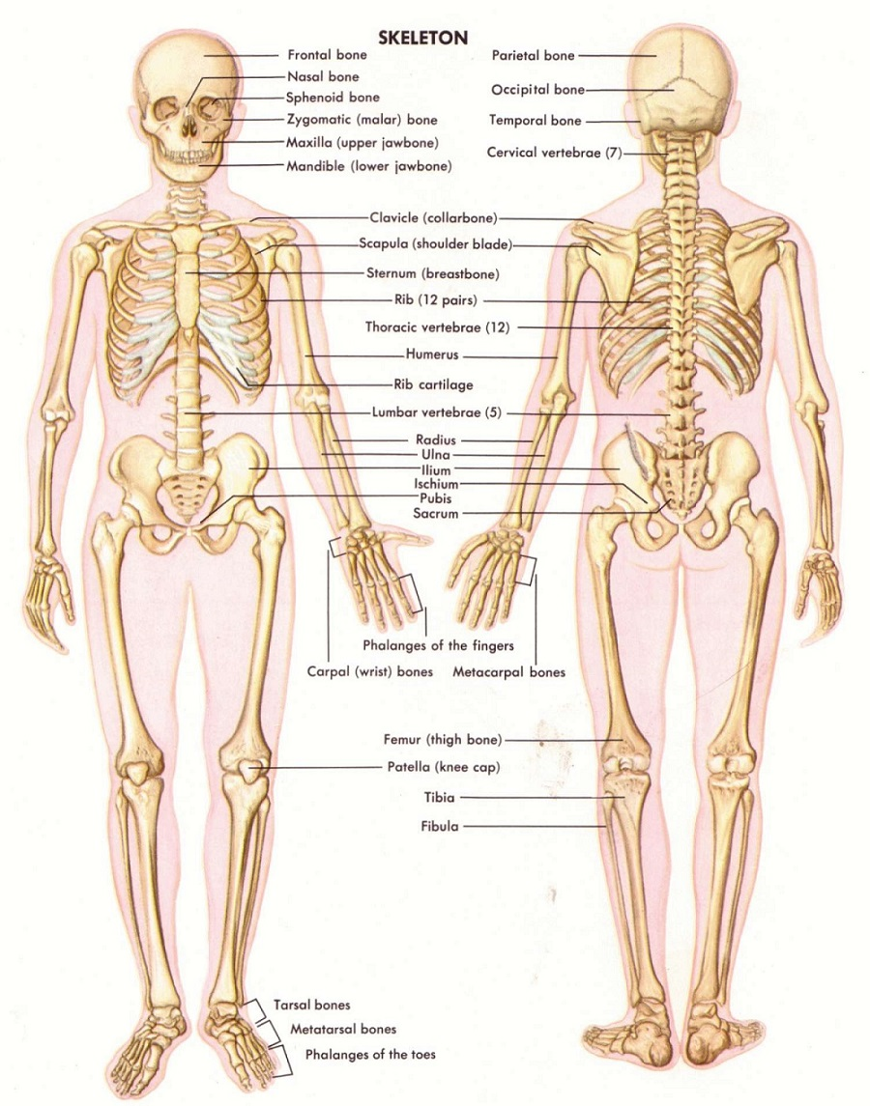

Attach more details as required

ISSUE INJURY CLASSIFICATION and ESCALATION requirement

